

WaveWatch Project Phase A

**Supervisor: Dr. Reuven Cohen**

**Students: Eyal Cohen & Lior Zucker**

**liorzucker11@gmail.com**

**eyalaxl135@gmail.com**

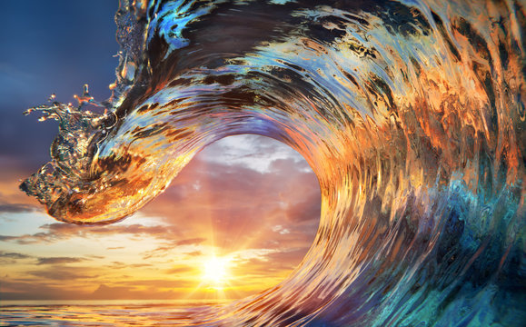

***Table of Contents***

**1. Abstract 4**

**2. Introduction 5**

**3. Literature Review 7**

3.1 Background: 7

3.1.1 Wave Height 7

3.1.2 Swell Direction 7

3.1.3 Crowd Density 7

3.1.4 Swell Period 7

3.1.5 Wind Direction 8

3.1.6 wave duration 8

3.1.7 wave count per swell duration 8

3.2 Used parameters in our project 8

3.3 Related Work: 9

3.3.1 Classification of Surf Breaks: 9

3.3.2 Artificial intelligence for beach monitoring: 10

3.3.3 Analysis of waves using Beach Webcams: 11

3.3.4 Beach Monitoring: 12

3.3.5 Key Parameters for Optimal Surfing Wave Conditions 13

3.4 Existing Tools for Surf Condition Analysis 14

3.4.1 Beach Cameras: 14

3.4.2 Wave Forecasts: 14

3.4.3 Weather Forecasts: 14

3.5 computer vision background 15

3.5.1 Image Classification Using Machine Learning 15

3.5.2 CNN Image Classification 15

3.5.3 YOLO (You Only Look Once) 15

**4. Engineering Process 16**

4.1 Product 17

4.1.1 Product Architecture 17

4.1.2 use case : 18

4.1.3 User Interface: 20

4.1.4 Activity Diagram 23

4.1.5 Package Diagram 24

4.1.6 Requirements 25

4.1.6.1 Functional Requirements 25

4.1.6.2 Non-Functional Requirements 26

4.2 Process 27

4.2.1 Methodology 27

4.2.2 Research: 27

4.2.3 Parameter Definition: 27

4.2.4 Concept and Documentation: 28

4.2.5 Data Gathering and Annotation: 28

4.2.6 Model Training: 28

4.2.7 Backend and Frontend Development: 28

4.2.8 Testing and Optimization: 28

4.2.9 Final Adjustments: 29

4.2.11 Expected Achievements: 30

4.2.11.1 Product Infrastructure and Flow: 30

4.2.11.2 Criteria for Success: 30

4.2.11.3 Unique Features: 31

4.2.11.3.1 Model: 31

4.2.11.3.2 Unique Parameters for Wave Analysis: 31

4.2.11.3.3 All-in-One Solution: 31

4.2.11.3.4 Real-time Insights: 31

4.3 Testing Plan 32

**5. References: 36**

**6. Appendices 37**

# 1. Abstract

Surfing enthusiasts often face challenges in identifying the best conditions for catching waves, especially when considering skill level and current sea conditions. Human observation is limited in tracking and analysing real-time sea dynamics, which is crucial for safe and effective surfing.

WaveWatch is a machine learning based software application developed to enhance the analysis of sea conditions through beach video footage. Utilising the YOLO (You Only Look Once) architecture, the software processes videos to provide insights beyond human capabilities. A wide range of beach videos capturing various sea conditions and crowd densities will be collected and annotated with features like wave types and surfer counts to train the model.

The analysis will focus on critical parameters: swell period, wave duration , wave count per swell period and surfer count. The swell period will be calculated by measuring overall time of incoming waves, helping to predict patterns.wave duration will be assessed to determine the quality of a wave, while surfer counts will be used to estimate crowd density, which impacts overall surfing conditions, lastly wave count per swell duration will help extract the quality of a swell period.

Once trained, the model will process new video footage, extracting detailed insights into sea conditions. The results will be presented via visualisations. WaveWatch’s user-friendly design allows users to upload beach videos and receive comprehensive analyses, benefiting a wide range of users, including surfers, swimmers, lifeguards, and beach managers.

By integrating AI with real-time data, WaveWatch aims to improve beach safety and optimise surfing and water-based activities.

# 2. Introduction

Surfing enthusiasts often struggle to accurately predict when conditions are optimal for catching waves. Factors such as swell period, wave duration, and crowd density are all crucial to the surfing experience, but assessing these variables manually is often time-consuming and unreliable. Human observation, while valuable, is limited in its ability to track the fast-changing dynamics of the sea. **WaveWatch** is a machine learning-based software application designed to address these challenges, allowing surfers to better understand sea conditions by analysing video footage of the beach and ocean.

WaveWatch utilises the YOLO (You Only Look Once) deep learning architecture to process video content and deliver comprehensive, data-driven insights. By simply uploading a video of the beach or ocean, users receive detailed analyses on whether the current conditions are favourable for surfing. The app focuses on key parameters such as swell period, wave duration, wave count per swell period, and surfer count to provide a well-rounded evaluation of the sea. The swell period, which is calculated by measuring the overall time of incoming waves, helps predict wave patterns and quality. Wave duration is analysed to determine the quality and rideability of each wave, offering surfers insight into how long they can expect to ride a wave. Additionally, the surfer count gives users an estimate of crowd density, which can influence the overall surfing experience by affecting both safety and wave accessibility.

WaveWatch is designed with user convenience in mind. The app features an intuitive interface where users can easily upload their beach videos. Once uploaded, the software processes the footage and delivers an in-depth report via visualisations and data summaries. These insights allow surfers to make informed decisions about whether or not it is a good time to head out into the water, eliminating the guesswork and uncertainty often associated with surfing. By automating the analysis of sea conditions, WaveWatch provides surfers with real-time, objective data that helps them better plan their sessions.

Beyond surfers, WaveWatch is a valuable tool for a range of other beachgoers, including lifeguards and beach managers. Lifeguards can use the data to monitor crowded areas and identify any potential risks, while beach managers can track overall crowd density and environmental conditions to make informed decisions regarding beach operations and safety protocols.

The development of WaveWatch is built on a foundation of extensive datasets comprising annotated beach videos. These videos capture various sea conditions, wave types, and crowd behaviours, ensuring that the machine learning model can be trained to accurately analyse new footage under diverse circumstances. Once the model is fully trained, it processes new videos uploaded by users in real-time, providing accurate and reliable data.

Book Contents:

Literature Review  
Key research and studies related to surf condition parameters and the use of technology for beach monitoring.

* 3.1 Background: Discussion of wave height, swell direction, crowd density, swell period, and other key ocean parameters relevant to the project.
* 3.2 Project Focus: A look at how this project targets specific parameters.
* 3.3 Related Work: Examination of existing research on surf break classification, AI in beach monitoring, and webcam analysis.
* 3.4 Existing Tools: Overview of current tools for surf condition analysis like beach cameras, wave forecasts, and weather forecasts.
* 3.5 Computer Vision: Basics of machine learning and image classification techniques, including YOLO.

Engineering Process  
Details on the project’s development process, from planning to deployment.

* 4.1 Product Development: Product architecture, UI design, and prototypes.
* 4.2 Process: The step-by-step workflow, including data collection, annotation, model training, and integrating the trained model into the app for wave analysis.

Testing Plan  
Explanation of the testing strategy and methodologies to ensure the app functions as expected.

References  
A list of all sources cited throughout the document.

Appendices  
Supplementary materials, including diagrams, data, and other relevant documents.

# **3. Literature Review**

## 3.1 Background:

This section will detail key parameters such as wave height, swell direction, crowd density, swell period, wind direction, tide, and water temperature. By understanding these factors, surfers can make informed decisions about the best times and locations for their activities. The aim is to present this information in a way that is both accessible and relevant, helping surfers of all skill levels optimize their time on the waves and enjoy a safer, more fulfilling experience.

### 3.1.1 Wave Height

Wave height is a crucial factor in determining good surfing conditions. Ideal wave heights can vary depending on the surfer’s skill level and preferences. Beginners can have an exhilarating experience even with waves of 70 cm, while experienced surfers look for waves of at least 1 or 2 meters.

### 3.1.2 Swell Direction

The direction of the swell, which is the wave system created in the open sea due to a storm, moving towards the shore, is essential for an ultimate surfing experience. In Israel, the optimal swell is a westerly swell. Sometimes, southwesterly or northwesterly swells may occur, and surfing should be adjusted to the precise angle at which the waves break on the shore. Additionally, the direction of the wave opening is important, with left-breaking waves preferred by goofy-footed surfers and right-breaking waves preferred by regular-footed surfers.[5.6]

### 3.1.3 Crowd Density

The number of surfers in the water impacts the surfing experience. More surfers often indicate good wave conditions, as people have already tested the spot. However, less crowded spots allow for more waves to be ridden and create a safer environment. Evaluating the crowd density can help in choosing the best time and place to surf.

### 3.1.4 Swell Period

Swell duration refers to the period during which a series of waves, or swells, persist in a given location. It specifically indicates the length of time over which multiple waves occur. Understanding swell duration is crucial as it helps gauge the consistency of wave activity. A longer swell duration often signifies more extended periods of favourable wave conditions, enhancing the chances of good surf.

### 3.1.5 Wind Direction

Offshore winds (blowing from the land to the sea) are generally preferred as they create smoother, more rideable waves. Onshore winds (blowing from the sea to the land) can make the waves choppy and less ideal for surfing.[5.6]

### 3.1.6 wave duration

Beach wave duration refers to the amount of time a wave lasts from the moment it begins to break until it fully dissipates. It helps determine the quality of the wave for activities like surfing, with longer durations often providing better surfing conditions.

### 3.1.7 wave count per swell duration

Wave count per swell duration is the number of waves that occur during a single swell period, which is the time that more waves occur. It helps assess the consistency and quality of waves within that swell, with more waves often indicating better conditions for surfing.

## 3.2 Used parameters in our project

In our project, we chose to focus on the number of surfers, the swell period, wave duration, amount of surfers and wave count for swell period. These parameters provide valuable insights into the quality of surfing conditions and help predict the best times and locations for surfing.

## 

## 3.3 Related Work:

### 3.3.1 Classification of Surf Breaks:

Until now, very little information, engineering or scientific criteria were available to quantify the difficulty of a surfing wave. Earlier studies suggested that the degree of difficulty or surfability) of a wave may be defined as a function of breaker height and peel angle. James A. Hutt, Kerry P. Black and Shaw T. Mead

[5.1]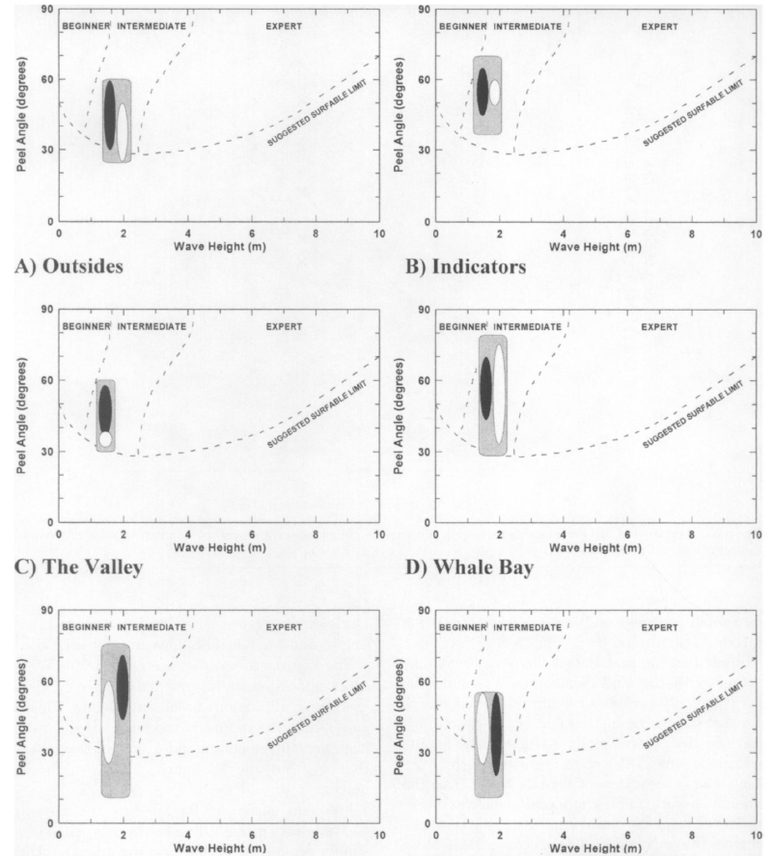

### 3.3.2 Artificial intelligence for beach monitoring:

This study proposes a novel approach to automating the counting process based on   
computer vision and artificial intelligence. Three HIKVISION PTZ surveillance cameras were installed on the roofs of strategic buildings of El Rodadero, Santa Marta, Colombia. This observation system provided more than 150,000 observations spanning more than a year (September 2022 – October 2023). An algorithm based on the YOLOv5 architecture was trained using a dataset containing over 50,000 labels of people at the beach or in water backgrounds. The model's user counts correlated strongly with human verification, achieving a coefficient of determination (R²) of 91%. These insights are critical for authorities to make informed decisions regarding beach management and for visitors to choose less crowded beaches, thereby preventing overcrowding.Richard Johnston-Gonzáleza, Eros Adarragaa, Oswaldo Cocaa, Marco Correaa.

[5.2]

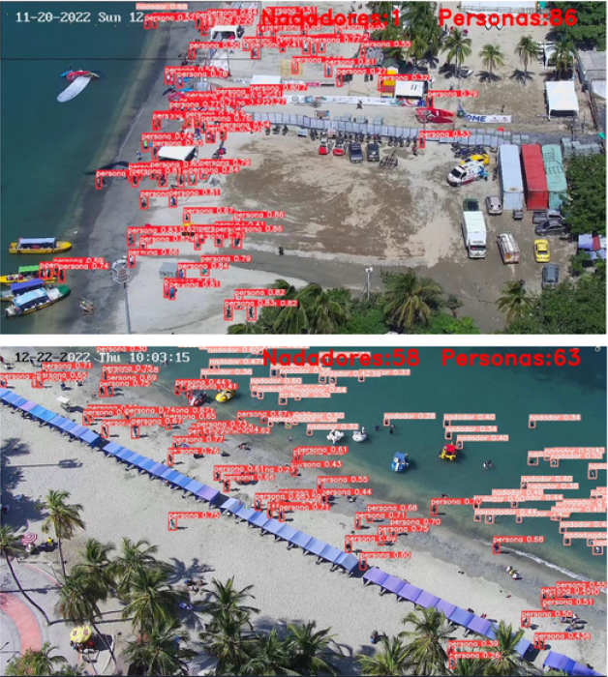

### 3.3.3 Analysis of waves using Beach Webcams:

Prior studies on this task have used videos from different sources for a variety of purposes, anging from the general study of wave breaking dynamics [5]–[7] or coastal monitoring [8] for analyzing surfing conditions [9], [10]. This task, like the task of people detection, was first approached using classical image processing methods [5], [9], and later with deep neural

networks [6]–[8], [10].Harel Mendelman, Tomer Masssas, Yair Moshe  
[5.3]

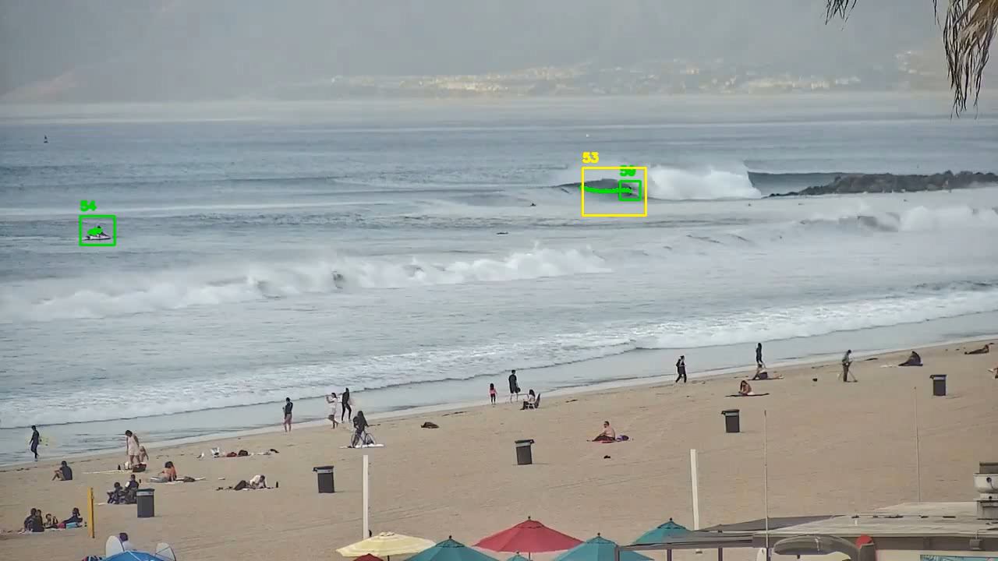

### 3.3.4 Beach Monitoring:

In this paper, an experimental study that uses IoT data and deep learning to predict the number of beach visitors at Castelldefels beach (Barcelona, Spain) was developed. Images of Castelldefels beach were captured by a video monitoring system. An image recognition software was used to estimate beach attendance.  
A deep learning algorithm (deep neural network) to predict beach attendance was developed. The experimental results prove the feasibility of Deep Neural Networks (DNNs) for beach attendance prediction. For each beach, a classification of occupancy was estimated, depending on the number of beach visitors. The proposed model outperforms other machine learning models (decision tree, k-nearest neighbors, and random forest) and can successfully classify seven beach occupancy levels with the Mean Absolute Error (MAE), accuracy, precision, recall and F1-score of 0.03, 92.7%, 92.9%, 92.7%, and 92.7%, respectively.Mari Carmen Domingo

[5.4]

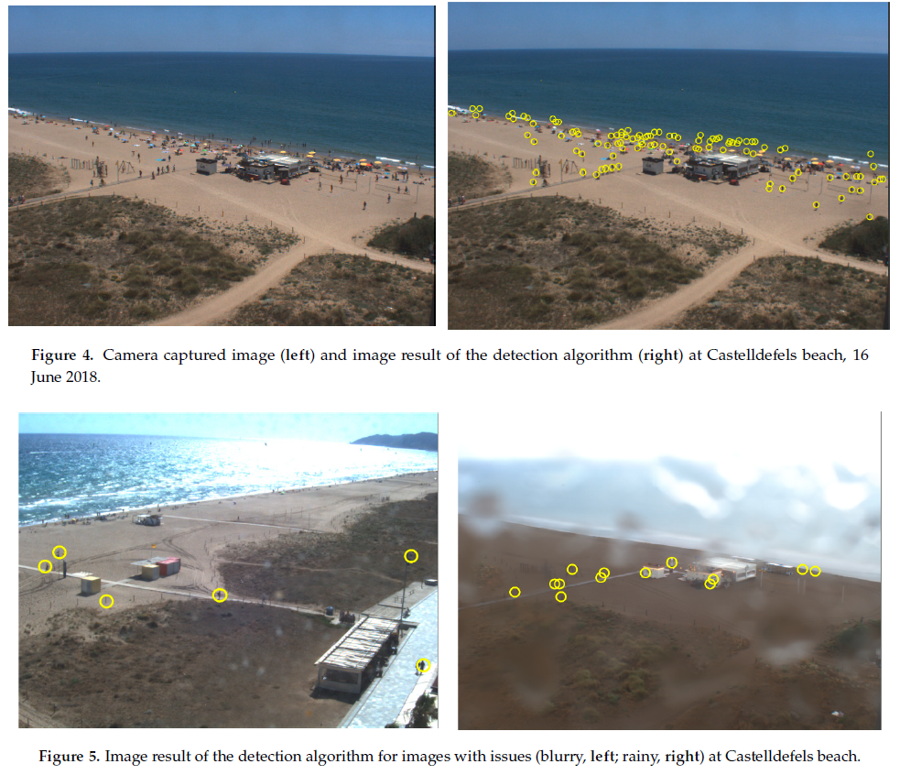

### 3.3.5 Key Parameters for Optimal Surfing Wave Conditions

Understanding the fundamental characteristics of a surfing wave is essential for evaluating good surf conditions. According to Scarfe et al. (2003), four primary parameters define optimal surfing waves: breaking wave height (Hb), wave peel angle (α), wave breaking intensity (BI), and wave section length (SL). Breaking wave height, measured from crest to trough, is crucial as it determines the size and power of the wave. The peel angle influences the wave's speed, requiring surfers to match their pace with the break. Wave breaking intensity, shaped by the seabed gradient, affects the wave’s force, with steeper waves providing more power for maneuvers. Lastly, wave section length dictates how surfers can navigate different parts of a wave, with changes in wave height, peel angle, or intensity offering varying opportunities for performance. These four parameters are vital for analyzing and predicting optimal surf conditions.[Scarfe, B. E.](https://escholarship.org/search/?q=author%3AScarfe%2C%20B.%20E.) , [Elwany, M. H.S.](https://escholarship.org/search/?q=author%3AElwany%2C%20M.%20H.S.) , [Mead, S. T.](https://escholarship.org/search/?q=author%3AMead%2C%20S.%20T.) , [Black, K. P.](https://escholarship.org/search/?q=author%3ABlack%2C%20K.%20P.) .  [5.5]

## 3.4 Existing Tools for Surf Condition Analysis

Modern technology offers several tools to track waves and beach status, providing surfers and beachgoers with essential information to determine optimal conditions. These tools include beach cameras, wave forecasts, and weather forecasts.

### 3.4.1 Beach Cameras:

Live streaming cameras installed on beaches allow real-time observation of wave conditions. Websites and apps host these streams, providing surfers with visual data to assess surf conditions.

### 3.4.2 Wave Forecasts:

Specialised websites and apps offer wave forecasts, predicting wave height, period, and direction. These forecasts are often based on data from meteorological and oceanographic models.  
**Surfline**: Employs a team of forecasters to provide daily updates and detailed wave forecasts. The forecasts are based on data from various meteorological sources and are presented in a user-friendly format.  
**goSurf**: Utilises data from leading meteorological and oceanographic companies to offer detailed wave forecasts and surf conditions.

### 3.4.3 Weather Forecasts:

Weather conditions significantly impact wave quality and beach safety. Accurate weather forecasts are crucial for planning surf sessions.  
**Windy**: Offers detailed weather forecasts, including wind speed and direction, which are critical factors for wave quality.  
**Magicseaweed**: Provides weather forecasts alongside wave predictions, helping surfers to understand the overall conditions.

### 

### 

### 

## 3.5 computer vision background

### 3.5.1 Image Classification Using Machine Learning

Image classification involves sorting images into one or more predefined categories. While humans can instinctively and easily categorise images, it's a more complex task for automated systems. Machine learning, particularly through the use of algorithms, enables systems to learn and identify patterns from both organised and unorganised datasets. One prominent machine learning approach for this task is deep learning, which uses multiple hidden layers within a model to achieve accurate classification.

### 3.5.2 CNN Image Classification

Convolutional Neural Networks (CNNs) are frameworks designed using machine learning principles. They can independently learn and train on data with minimal human intervention, requiring only some pre-processing. CNNs develop and adapt their own image filters, which otherwise need to be manually coded in most other algorithms and models. These networks comprise layers that perform various functions, enabling CNNs to carry out image classification tasks effectively.

### 3.5.3 YOLO (You Only Look Once)

YOLO is a state-of-the-art object detection algorithm known for its speed and accuracy. Unlike traditional object detection methods that use a region proposal network (RPN) to identify objects, YOLO frames object detection as a single regression problem, straight from image pixels to bounding box coordinates and class probabilities. Key features include:

* **Single Convolutional Neural Network**: YOLO uses a single CNN to predict multiple bounding boxes and class probabilities simultaneously.
* **Real-Time Detection**: Capable of processing images at high frame rates, making it suitable for real-time applications.
* **Accuracy**: YOLO achieves high accuracy in detecting objects, with a low rate of false positives.
* 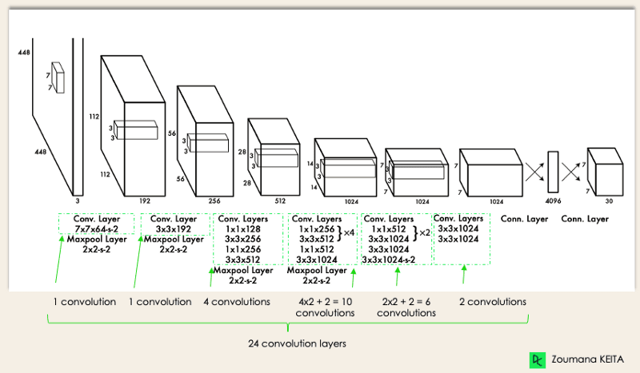**Applications**: Widely used in various applications such as autonomous driving, security surveillance, and sports analytics.

# 4. Engineering Process

The engineering process for developing WaveWatch involves creating a sophisticated app designed to provide real-time sea condition analysis. The process begins with gathering and analysing user requirements to define key features. We then design a system architecture using the YOLO (You Only Look Once) algorithm for efficient and accurate object detection. Following this, we collect and preprocess video data to train our AI model for detecting and analysing sea conditions. The app is developed with a focus on a user-friendly interface that delivers clear and actionable insights. Finally, extensive testing and optimization ensure that the app operates reliably and meets user expectations, offering valuable real-time information in an accessible format.

## 

## 4.1 Product

### 4.1.1 Product Architecture

#### 

WaveWatch project employs a streamlined architecture to analyse beach videos and assess sea conditions. The process begins with the user uploading a video into the application. Using advanced computer vision techniques based on the YOLO architecture, the system detects and identifies surfers and waves within the video. Once detected, the application tracks the movement of both surfers and waves over time to gather comprehensive data. This data is then subjected to a detailed analysis to evaluate various sea conditions, including swell period,wave duration,surfers count, wave count per swell period. The resulting insights help determine whether the conditions are favourable for surfing. Through this robust workflow, WaveWatch provides users with actionable information to enhance their beach experience and ensure safety.

### 4.1.2 use case :

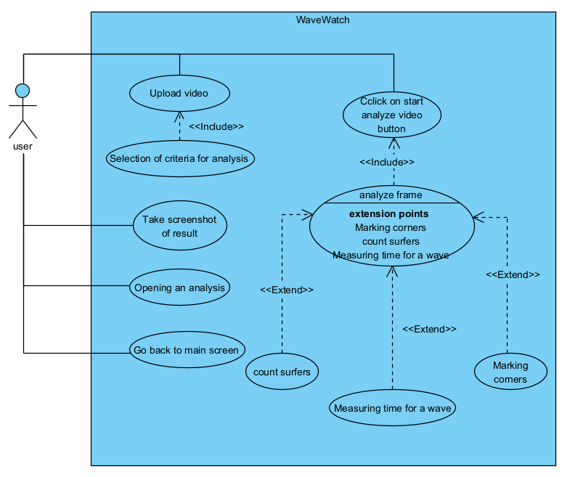This use case diagram represents the "WaveWatch" system, outlining how a user interacts with the application to analyze sea and surfing conditions. The process begins when the user uploads a video, which is a prerequisite for all subsequent actions. Once the video is uploaded, the user can select specific criteria for analysis, such as counting surfers or measuring wave time. These criteria guide the system on what aspects of the video to focus on during the analysis. Both the "Upload Video" and "Selection of Criteria for Analysis" use cases are mandatory and are connected to the core functionality of the system with an <<include>> relationship, meaning they must be completed before the main analysis can proceed.

Once these steps are fulfilled, the user clicks the "Start Analyze Video" button to trigger the system's processing. The main operation, "Analyze Frame," is central to the system and involves AI-driven analysis of the video frames. This use case is extendable, meaning additional functionalities can be added depending on user needs or specific conditions. The three key extension points—marking corners, counting surfers, and measuring wave time—are optional features that enhance the analysis. These use cases are connected to the main "Analyze Frame" through an <<extend>> relationship, meaning the system can extend the core analysis by including these additional operations if needed. For example, the user might choose to count surfers or measure the time a wave takes to form, depending on the selected criteria for analysis.

The system also allows the user to take a screenshot of the analysis result, giving them a visual snapshot of the data. These features are directly related to the user's interaction after the analysis is complete and serve to improve usability by allowing quick access to data and results. The "Go Back to Main Screen" use case provides the user with a navigation option, ensuring they can return to the dashboard at any point.

### 4.1.3 User Interface:

The user interface (UI) of the WaveWatch application will be designed to be intuitive and user-friendly, allowing users to interact seamlessly with the analysis results.  
The UI will include:

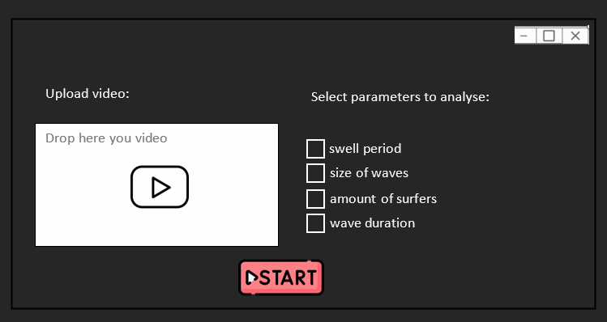

The first screen, serves as the entry point for users. Here, users have the option to upload a video of the waves they want to analyse. They can also select specific sea parameters that they are interested in examining, such as swell period or wave duration. Once these parameters are chosen, users can initiate the analysis by pressing the "Start" button. This action transitions the user to the next screen.

### 

The second screen is the Loading Screen. This screen is displayed while the application processes the video. During this phase, a visual indicator, such as a progress bar or animation, shows that the system is working on calculating the relevant data. This screen helps users understand their current position in the process.By offering a clear indication of progress, the Loading Screen ensures users are informed and can manage their expectations while waiting for the results. This stage is crucial for the application to generate accurate analysis results based on the uploaded video.

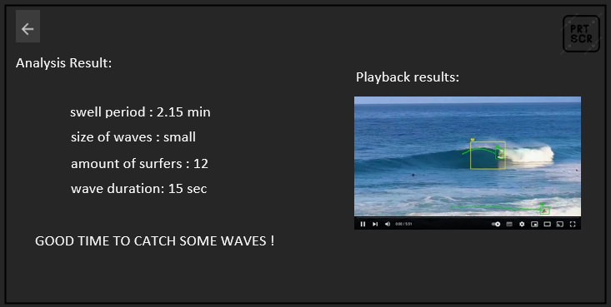

Finally, the third screen, called the Analysis Screen, presents the results of the video analysis. The analysed video is displayed with annotations that highlight important findings, such as waves detections and other critical metrics. Alongside the video, the parameters selected by the user are shown for reference. Additionally, users have the option to screenshot the analysis, making it easy to save and review. After reviewing the results, users can return to the Dashboard to upload new videos or adjust the parameters for further analysis.

### 4.1.4 Activity Diagram

This activity diagram outlines the user and system interactions for the WaveWatch application. The process begins when the user launches WaveWatch by running the application. The next step for the user is to upload a video, which is then checked by the system to ensure that the video format is valid. If the video format is invalid, the system prompts the user to upload a valid video.

Once the video format is confirmed as valid, the user is presented with the option to select various parameters for analysis. The system waits until the user completes their parameter selection. If the user hasn't finished, they can continue choosing parameters. After the user completes the selection, they click the "Start" button, triggering the analysis based on the chosen parameters.

The system then moves into the analysis phase, displaying a loading screen while the video is processed. Once the analysis is complete, the system displays the results on a popup screen. If the analysis is still ongoing, the system refreshes the loading screen until the process finishes.

After the analysis results are displayed, the user is given two options: either conduct another analysis or take a screenshot of the current results. If the user chooses to take a screenshot, the system captures and saves the analysis results. The user can then return to the start by clicking the back button, repeating the process or ending the session.

This flow ensures a user-friendly interaction with clear decision points, providing a seamless experience while analyzing videos for sea conditions.

### 

### 4.1.5 Package Diagram

The diagram primarily highlights the Sea Condition Analysis Package, which is responsible for processing key sea condition parameters such as the swell period, wave duration, wave count for a given swell period, and the surfer count. This package relies on input from the Video Processing Pipeline, which utilises a YOLO model for object detection. The model generates bounding boxes and labels for each detected object in video frames, such as surfers or waves. A Frame Extraction Service within the pipeline prepares video frames for analysis by isolating them from the uploaded video footage. The interaction between the sea condition analysis and video processing components is key to the system's functionality, enabling accurate detection and measurement of various sea and crowd parameters from the video data. The backend coordinates these processes, while the user interface serves as an entry point for video uploads and output visualisation, though it plays a lesser role in the core functionality compared to the analysis and processing packages.

### 

### 4.1.6 Requirements

The feedback from the surfing community survey significantly influenced the functional and non-functional requirements of the WaveWatch project. Functionally, the surfers emphasised the need for real-time data on wave conditions, such as swell period, wave duration, and surfer count, leading to the integration of these parameters into the model. Their input ensured the system would deliver accurate and timely information, helping surfers plan their sessions more effectively. Non-functionally, the survey underscored the importance of a simple and responsive interface that even beginner surfers could navigate easily, while also ensuring reliability for more experienced users who depend on precise data for advanced surfing activities.

#### 4.1.6.1 Functional Requirements

1. Video Upload and Management:
   * Users must be able to upload beach videos in standard formats (e.g., MP4).
   * The system should support batch uploading and provide progress indicators.
2. Video Processing:
   * The system must extract frames from videos at configurable intervals.
   * The YOLO model should detect and classify objects within the frames, including waves and surfers.
3. Parameter Detection:
   * The system should accurately identify and measure key parameters such as wave length, swell period, attack period, number of surfers, and wave duration.
   * Detected parameters must be displayed with confidence scores and visual markers on the video.
4. User Interface:
   * Users must have access to a dashboard displaying summarised metrics of video analysis.
   * A video playback feature should allow users to view the processed video with overlaid detection results.
   * The system should offer detailed reports with graphical representations of detected parameters.
5. Customizable Views:
   * The system should allow users to filter and analyse specific parameters of interest.
6. Error Handling and Notifications:
   * The system must handle errors gracefully and provide clear error messages to the user.
   * Notifications should inform users about the status of video processing and any issues encountered.

#### 4.1.6.2 Non-Functional Requirements

1. Performance:
   * The system must process videos and provide results within a reasonable timeframe, depending on video length and complexity.
   * The YOLO model should deliver detection results with high accuracy and minimal latency.
2. Scalability:
   * It must be designed to scale with increasing numbers of users and video data.
3. Usability:
   * The user interface must be intuitive and easy to navigate, with clear instructions and tooltips.
   * The system should provide a responsive design that works well on various screen sizes and resolutions.
4. Reliability:
   * The system must be robust and handle unexpected failures or interruptions without data loss.
5. Compatibility:
   * The application should be compatible with major operating systems (e.g., Windows, macOS) and standard video formats.
   * It must function correctly with varying hardware configurations, including different types of video cameras.
6. Maintainability:
   * The system codebase should be well-documented and modular, facilitating easy updates and maintenance.
   * The system should support version control to manage changes and track modifications over time.
7. Documentation:
   * Comprehensive user documentation should be provided, including guides for video upload, analysis, and report generation.
   * Technical documentation should detail the system architecture, algorithms used, and data structures for developers.

These requirements will ensure that the WaveWatch system is effective in analysing beach videos while being reliable, secure, and user-friendly.

## 

## 4.2 Process

The process for developing WaveWatch involves defining user requirements, designing an efficient system architecture using the YOLO algorithm, and training AI models with video data. The app is then developed with a user-friendly interface for real-time analysis and undergoes thorough testing and optimization to ensure reliability and performance.

### 4.2.1 Methodology

For the development of WaveWatch, we employ the Agile methodology to ensure flexibility, continuous improvement, and iterative progress. This approach is well-suited for projects involving complex AI systems and dynamic user requirements.

#### 4.2.2 Research:

The research phase primarily focused on studying papers related to beach monitoring and wave analysis to understand the technical and environmental aspects crucial to the app. In addition to exploring academic literature, We conducted a questionnaire by distributing it to local surfing groups, gathering feedback from the community. Giving us valuable insights into what features and parameters surfers wanted to see in the app. We used this feedback to guide both the functionality of the app and the selection of the parameters for analysing the videos. This helped us shape the app’s features based on real-world user needs. Alongside this, we explored the YOLO architecture to understand how it could be applied for real-time object detection in wave and surfer analysis.

#### 4.2.3 Parameter Definition:

As part of the conceptualization phase, we defined the parameters that the app would analyse. The selection of these parameters, such as wave height, swell period, and surfer count, was driven by their relevance to the intended users. We chose features that would provide real value, focusing on delivering accurate, actionable insights to improve the beach-going and surfing experience. This careful selection was motivated by the need to ensure that the app’s functionality aligns with real-world demands.

#### 

#### 4.2.4 Concept and Documentation:

With the technical groundwork in place, we moved on to outlining the core functionality of the app. The app's flow was mapped out, starting from video upload to parameter selection and analysis playback. This stage allowed us to draft a user-friendly interface and a seamless workflow. All the findings and conceptual work were compiled into a comprehensive book, which serves as the theoretical foundation of the project. This document covers the rationale, technical decisions, and the full scope of the project, forming the blueprint for the next phase.

#### 4.2.5 Data Gathering and Annotation:

The second semester will be focused on practical development, starting with data gathering. We will collect video footage from beaches, ensuring the data covers a wide range of conditions. Afterward, the videos will undergo annotation, where key objects like waves and surfers are labelled. This step is essential for creating a robust dataset to train the YOLO model, as the accuracy of the annotations will directly affect the model’s performance.

#### 4.2.6 Model Training:

Using the annotated data, we will train the YOLO model to detect and track the selected parameters. The motivation behind choosing YOLO is its ability to perform real-time detection with high accuracy. The training process will involve fine-tuning the model to accommodate the nuances of beach environments, ensuring that it delivers reliable results even in varying wave conditions.

#### 4.2.7 Backend and Frontend Development:

Once the model is trained, it will be integrated into the backend of the app. This integration will allow users to upload videos and receive analysis results based on their selected parameters. The backend will be optimised to handle the processing efficiently, while the frontend will offer an intuitive user interface. Users will be able to play back their videos with bounding boxes on detected objects, view statistics on chosen parameters, and take screenshots of the analysed footage.

#### 4.2.8 Testing and Optimization:

Throughout the implementation phase, the app will undergo extensive testing. This will involve testing the app across different devices and with various video inputs to ensure robustness and performance. The motivation here is to refine the app continuously, optimising both backend and frontend components for speed, accuracy, and usability.

#### 

#### 4.2.9 Final Adjustments:

In the final stage, we will gather feedback from users and fine-tune the app to meet all performance and usability goals. The adjustments made at this stage will ensure that the app is not only functional but also delivers a smooth, reliable user experience that aligns with the goals set out in the research phase.

This two-semester approach ensures that the project moves from a solid research foundation to a fully implemented and refined application, guided by clear motivation and thoughtful execution at every step.

4.2.10 conclusion:

1. Research and Conceptualization: Studied relevant literature, focusing on YOLO for video analysis.
2. Parameter Definition: Selected key parameters like wave height, swell period, and surfer count.
3. Concept and Documentation: Mapped out app functionality and documented the process in a book.
4. Data Gathering and Annotation: Collected and annotated videos to train the YOLO model.
5. Model Training: Trained YOLO for wave and surfer detection, optimising for beach conditions.
6. Backend and Frontend Development: Integrated the model, developed video playback with bounding boxes, statistics, and screenshot features.
7. Testing and Optimization: Conducted rigorous testing, refining backend and frontend for performance and usability.
8. Final Adjustments: Gathered user feedback and fine-tuned the app for optimal performance and user experience.

### 4.2.11 Expected Achievements:

Our product, WaveWatch, aims to revolutionise how surfers and beach-goers experience real-time sea conditions. By leveraging advanced AI technology, our system will deliver a fast, intuitive, and (hopefully) highly accurate analysis of wave and sea conditions, catering to both novice and experienced users.

The user-friendly interface will simplify the complex task of evaluating sea conditions, providing clear and actionable insights quickly. Whether it's for planning the perfect surf session, ensuring safety for swimmers, or optimising fishing trips, WaveWatch will offer a streamlined and efficient solution for all stakeholders.

#### 4.2.11.1 Product Infrastructure and Flow:

Data Acquisition: Integrate video feeds to collect data on sea conditions, including wave characteristics and surfer activity.  
AI Processing: Apply YOLO-based convolutional neural networks (CNNs) to analyse the collected data, detecting and classifying key parameters such as wave pockets, surfer counts, and time intervals.  
Information Delivery: Design and implement an app interface that presents analysed data through user-friendly visualisations.

#### 4.2.11.2 Criteria for Success:

Analysis Accuracy: Achieve 0.8 probability of true detection both for waves and surfers, with such accuracy the app could deliver precise analysis of chosen parameters.  
User Satisfaction: Obtain positive feedback from a diverse user base, indicating that the interface is intuitive, the data is accessible, and the system meets their needs effectively.  
System Reliability: Ensure robust system performance with minimal analysis process time (up to 3 times the input video’s actual duration) and consistent accuracy across different weather conditions and times of day.

### 

#### 4.2.11.3 Unique Features:

#### 4.2.11.3.1 Model:

The project utilises a YOLO model trained on a custom, annotated dataset that we specifically gathered for beach environments. This ensures accurate detection of both waves and surfers, providing precise insights tailored for real-world surfing conditions. The unique dataset makes the detection more reliable than using generalised models, enhancing the app's performance.

#### 4.2.11.3.2 Unique Parameters for Wave Analysis:

Our app stands out by analysing a set of unique parameters that go beyond typical metrics. These include wave duration, wave count per swell duration, swell period, and crowd density. These parameters offer surfers detailed insights into wave quality, consistency, and beach activity, helping them make more informed decisions about when and where to surf.

#### 4.2.11.3.3 All-in-One Solution:

The app is designed as a comprehensive tool that combines video analysis, parameter tracking, and real-time detection. It allows users to upload videos, analyse them based on their chosen parameters, and get detailed insights—all in one platform. No other app offers such an integrated approach, making it a groundbreaking tool for surfers and beachgoers.

#### 4.2.11.3.4 Real-time Insights:

With the ability to playback analysed videos with bounding boxes and offer statistics on the selected parameters, users can quickly understand current beach and wave conditions. The inclusion of crowd density monitoring also adds an extra layer of safety and decision-making for surfers, further setting the app apart from existing tools.

## 4.3 Testing Plan

Test 1: run WaveWatch application.

|  |  |  |
| --- | --- | --- |
| # | Action | Expected Result |
| 1 | Run app.py on application directory | WaveWatch application should be started with Start screen |

Test 2: upload a video to WaveWatch application.

|  |  |  |
| --- | --- | --- |
| # | Action | Expected Result |
| 1 | Run app.py on application directory | WaveWatch application should be started with Start screen |
| 2 | Drag a .mp4 file to dedicated space on the app | Video uploaded successfully pop up |

Test 3: choose parameters to analyse on WaveWatch application.

|  |  |  |
| --- | --- | --- |
| # | Action | Expected Result |
| 1 | Run app.py on application directory | WaveWatch application should be started with Start screen |
| 2 | Drag a .mp4 file to dedicated space on the app | Video uploaded successfully pop up |
| 3 | Mark the checkbox or boxes of parameters you want to analyse the video based on | Start button should be coloured at that point |

Test 4: analyse a video on WaveWatch application.

|  |  |  |
| --- | --- | --- |
| # | Action | Expected Result |
| 1 | Run app.py on application directory | WaveWatch application should be started with Start screen |
| 2 | Drag a .mp4 file to dedicated space on the app | Video uploaded successfully pop up |
| 3 | Mark the checkbox or boxes of parameters you want to analyse the video based on | Start button should be coloured at that point |
| 4 | Click on ‘start’ button | Loading screen popup |

Test 5: analyse a 2nd video on WaveWatch application.

|  |  |  |
| --- | --- | --- |
| # | Action | Expected Result |
| 1 | Run app.py on application directory | WaveWatch application should be started with Start screen |
| 2 | Drag a .mp4 file to dedicated space on the app | Video uploaded successfully pop up |
| 3 | Mark the checkbox or boxes of parameters you want to analyse the video based on | Start button should be coloured at that point |
| 4 | Click on ‘start’ button | Loading screen popup + analysis and playback screen popup |
| 5 | Click on ‘back’ button | Popsup first screen of video upload and parameters selection |
| 6 | Repeat steps 1-5 | Loading screen popup + analysis and playback screen popup |

Test 6: screenshot an analysis on WaveWatch application.

|  |  |  |
| --- | --- | --- |
| # | Action | Expected Result |
| 1 | Run app.py on application directory | WaveWatch application should be started with Start screen |
| 2 | Drag a .mp4 file to dedicated space on the app | Video uploaded successfully pop up |
| 3 | Mark the checkbox or boxes of parameters you want to analyse the video based on | Start button should be coloured at that point |
| 4 | Click on ‘start’ button | Loading screen popup + analysis and playback screen popup |
| 5 | Click on ‘prtscn’ button | A screenshot of the analysis page will be taken to a local directory running the app. |

## 

# 5. References:

5.1 Classification of Surf Breaks in Relation to Surfing Skillt James A. Huttf, Kerry P. Blackt and Shaw T. Meadt.

5.2 Artificial intelligence for beach monitoring: An experimental study of beach attendance at El Rodadero, ColombiaRichard Johnston-Gonzáleza, b, Eros Adarragaa, Oswaldo Cocaa, Marco Correaa.

5.3 Analysis of Waves and Human Interaction Using Beach Webcams Harel Mendelman Tomer Masssas Yair Moshe Signal and Image Processing Laboratory (SIPL), Andrew and Erna Viterbi Faculty of Electrical & Computer Engineering Technion – Israel Institute of Technology, Haifa, Israel.

5.4 Deep Learning and Internet of Things for Beach Monitoring:  
An Experimental Study of Beach Attendance Prediction at Castelldefels BeachMari Carmen Domingo

5.5 The Science of Surfing Waves and Surfing Breaks - A Review

5.6 How to Read Surf Forecast & What Makes It a Great Day to Surf?:  
[How to Read Surf Forecast & What Makes It a Great Day to Surf? - Lapoint Surf camps (lapointcamps.com)](https://www.lapointcamps.com/blog/how-to-read-surf-forecast/)

5.7 <https://beachcam.co.il/batgalim.html>

5.8 <https://www.surfline.com>

5.9 <https://github.com/ultralytics/yolov5>

5.10<https://docs.python.org/3/>

5.11 <https://colab.research.google.com>

5.12 <https://chatgpt.com>

# 6. Appendices

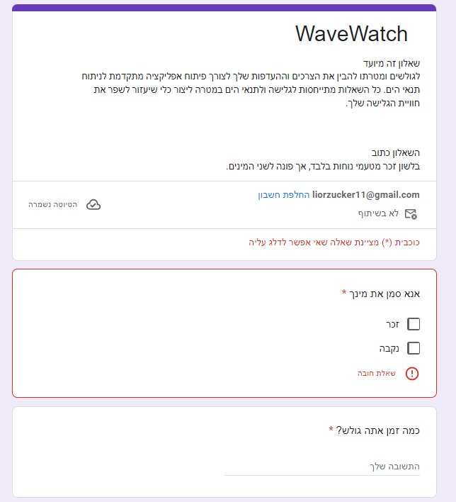

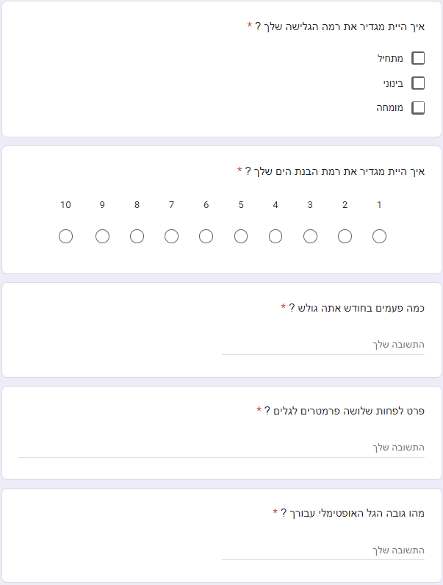

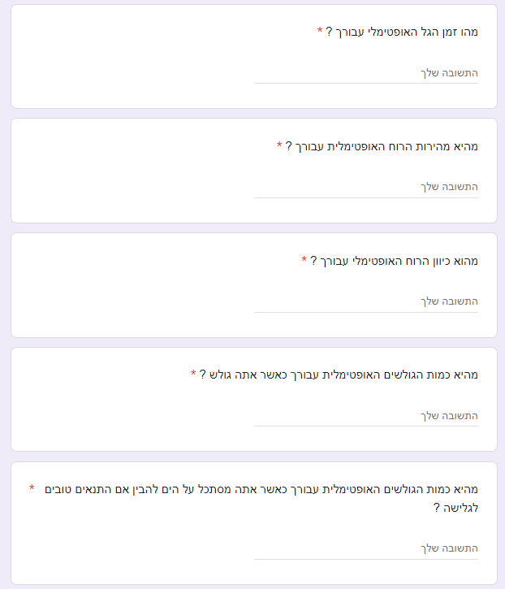

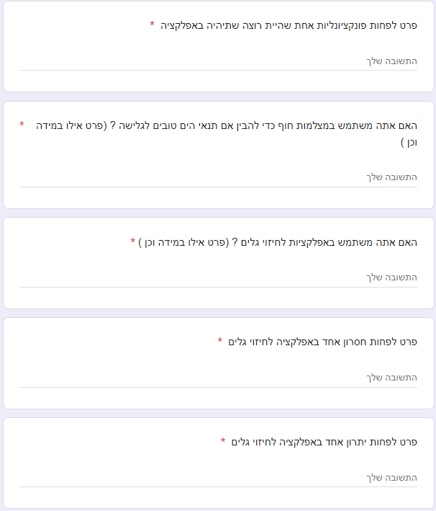

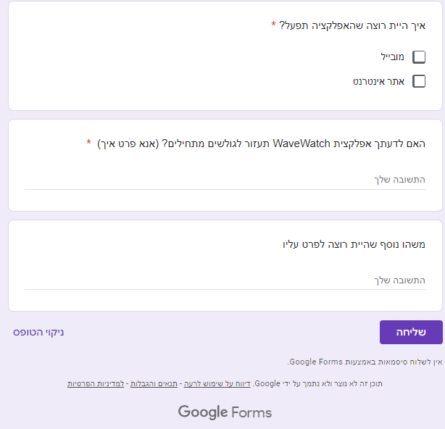

2.

